Chapter 5, Solution 26

Using Fig. 5.64, design a problem to help other students better understand noninverting op amps.

Although there are many ways to work this problem, this is an example based on the same kind of problem asked in the third edition.

Problem

Determine i_{o} in the circuit of Fig. 5.64.

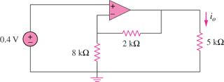

Figure 5.64

Solution

+

v_{b} - i_{o}
+ +
0.4V 5k
- 2k v_{o}
8k
-

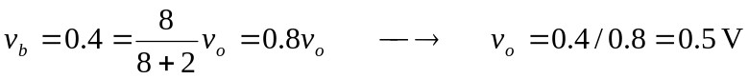
Hence,
